Logistic Regression in Machine Learning

* Logistic regression is one of the most popular Machine Learning algorithms, which comes under the Supervised Learning technique. It is used for predicting the categorical dependent variable using a given set of independent variables.
* Logistic regression predicts the output of a categorical dependent variable. Therefore the outcome must be a categorical or discrete value. It can be either Yes or No, 0 or 1, true or False, etc. but instead of giving the exact value as 0 and 1, **it gives the probabilistic values which lie between 0 and 1**.
* Logistic Regression is much similar to the Linear Regression except that how they are used. Linear Regression is used for solving Regression problems, whereas **Logistic regression is used for solving the classification problems**.
* In Logistic regression, instead of fitting a regression line, we fit an "S" shaped logistic function, which predicts two maximum values (0 or 1).
* The curve from the logistic function indicates the likelihood of something such as whether the cells are cancerous or not, a mouse is obese or not based on its weight, etc.
* Logistic Regression is a significant machine learning algorithm because it has the ability to provide probabilities and classify new data using continuous and discrete datasets.
* Logistic Regression can be used to classify the observations using different types of data and can easily determine the most effective variables used for the classification. The below image is showing the logistic function:

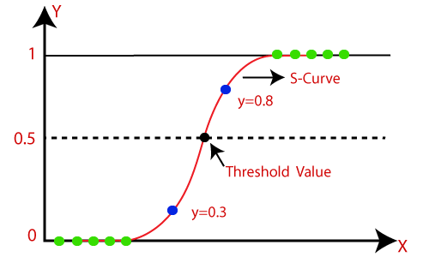

**Note:** Logistic regression uses the concept of predictive modeling as regression; therefore, it is called logistic regression, but is used to classify samples; Therefore, it falls under the classification algorithm.

Logistic Function (Sigmoid Function):

* The sigmoid function is a mathematical function used to map the predicted values to probabilities.
* It maps any real value into another value within a range of 0 and 1.
* The value of the logistic regression must be between 0 and 1, which cannot go beyond this limit, so it forms a curve like the "S" form. The S-form curve is called the Sigmoid function or the logistic function.
* In logistic regression, we use the concept of the threshold value, which defines the probability of either 0 or 1. Such as values above the threshold value tends to 1, and a value below the threshold values tends to 0.

AD

Assumptions for Logistic Regression:

* The dependent variable must be categorical in nature.
* The independent variable should not have multi-collinearity.

Logistic Regression Equation:

The Logistic regression equation can be obtained from the Linear Regression equation. The mathematical steps to get Logistic Regression equations are given below:

* We know the equation of the straight line can be written as:

Logistic Regression in Machine Learning

* In Logistic Regression y can be between 0 and 1 only, so for this let's divide the above equation by (1-y):

Logistic Regression in Machine Learning

* But we need range between -[infinity] to +[infinity], then take logarithm of the equation it will become:

Logistic Regression in Machine Learning

The above equation is the final equation for Logistic Regression.

AD

Type of Logistic Regression:

On the basis of the categories, Logistic Regression can be classified into three types:

* **Binomial:** In binomial Logistic regression, there can be only two possible types of the dependent variables, such as 0 or 1, Pass or Fail, etc.
* **Multinomial:** In multinomial Logistic regression, there can be 3 or more possible unordered types of the dependent variable, such as "cat", "dogs", or "sheep"
* **Ordinal:** In ordinal Logistic regression, there can be 3 or more possible ordered types of dependent variables, such as "low", "Medium", or "High".